VoterInformation

Table as per design

The Data type are the same

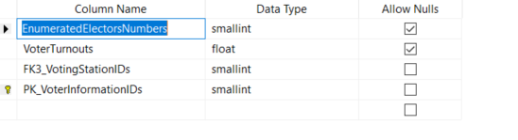

Rows retrieved 234 rows

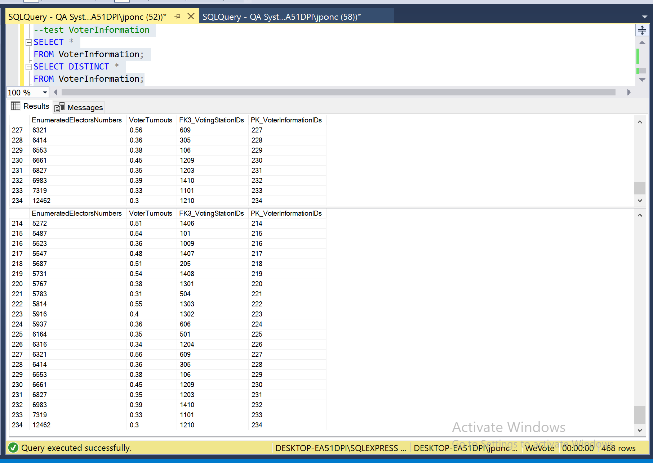

Data Manipulation

Primary Key - Explicit Insert for Identity Column

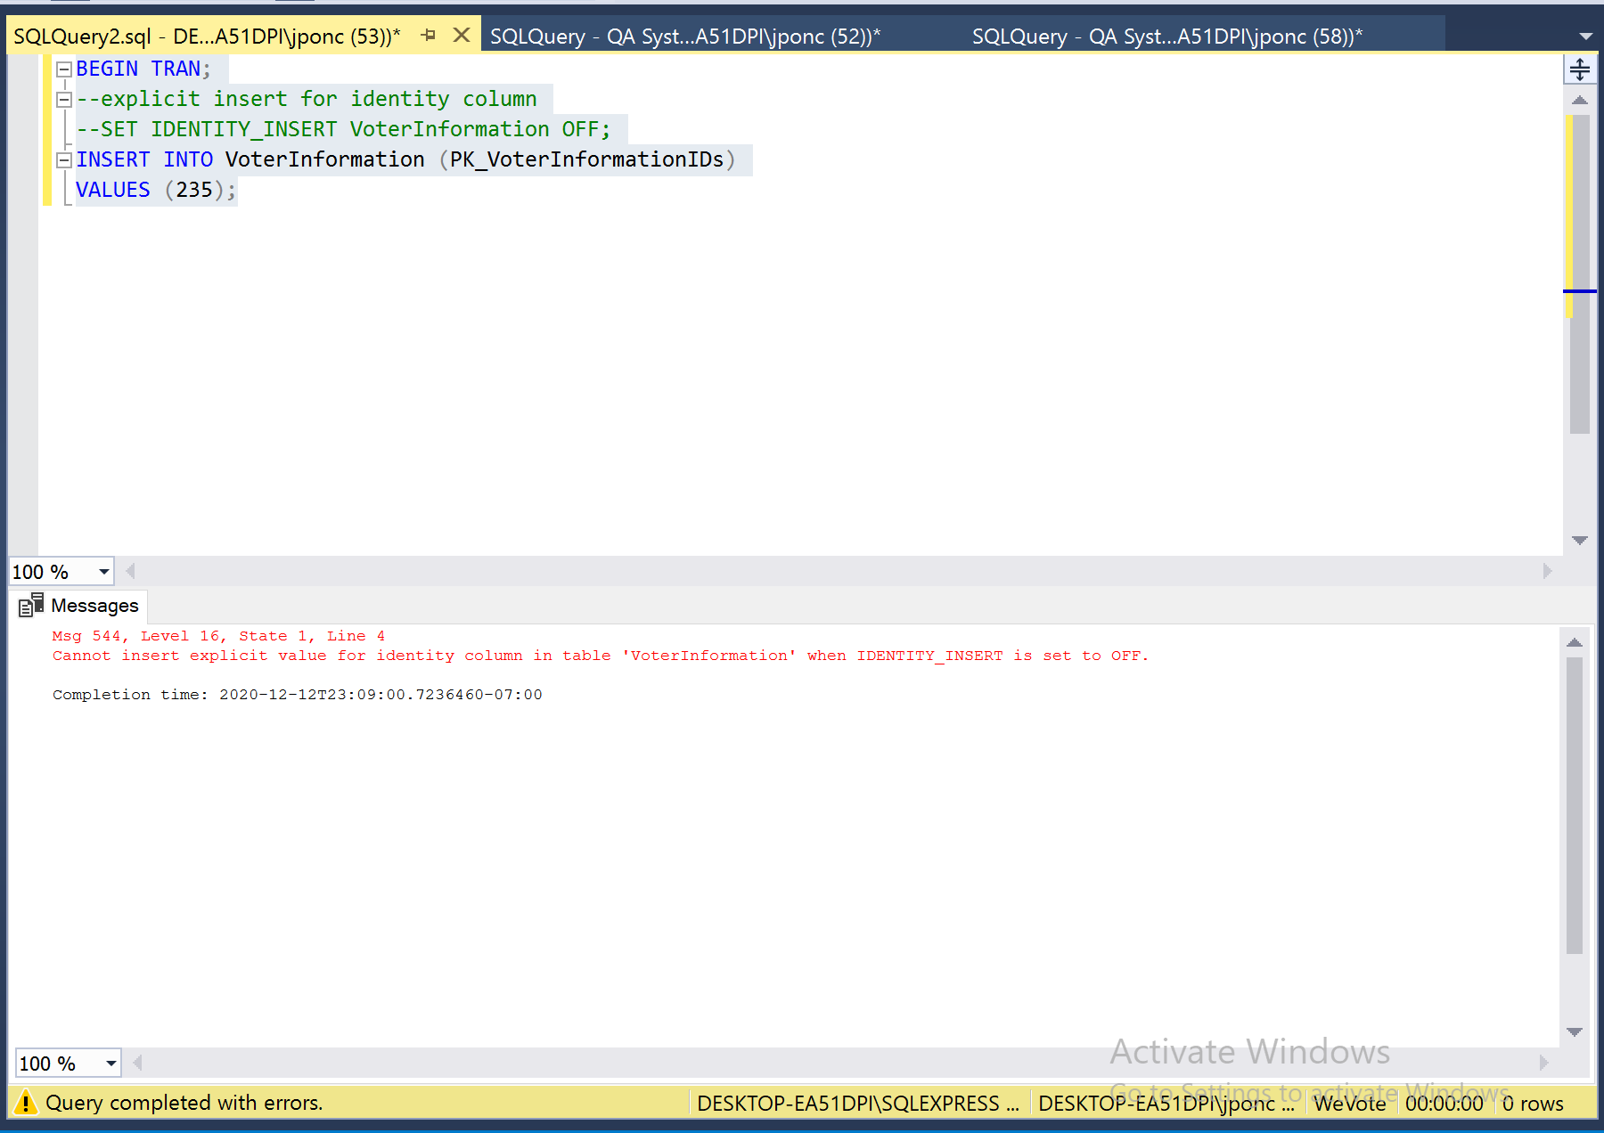

Primary Key – Update

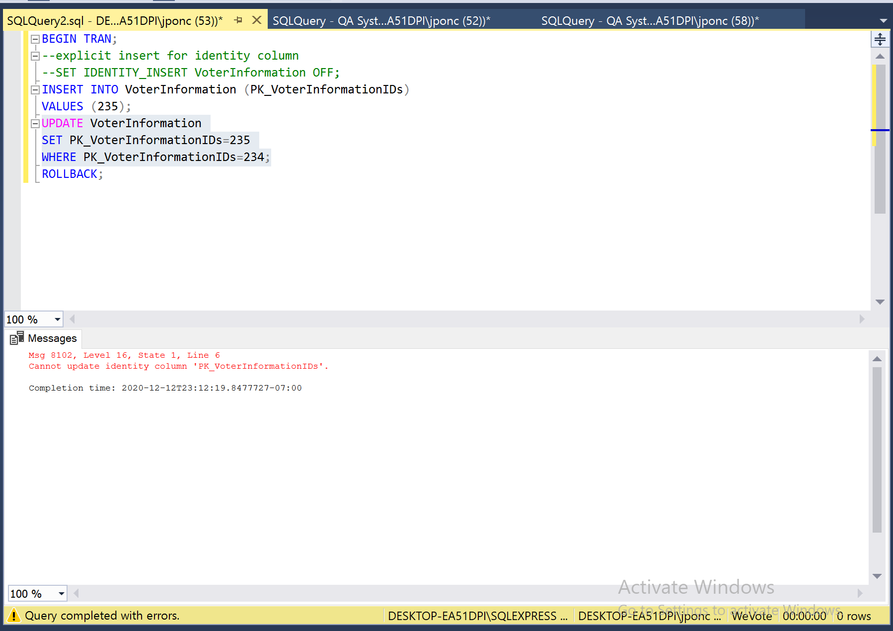

Primary Key not related to other table and with Foreign Key

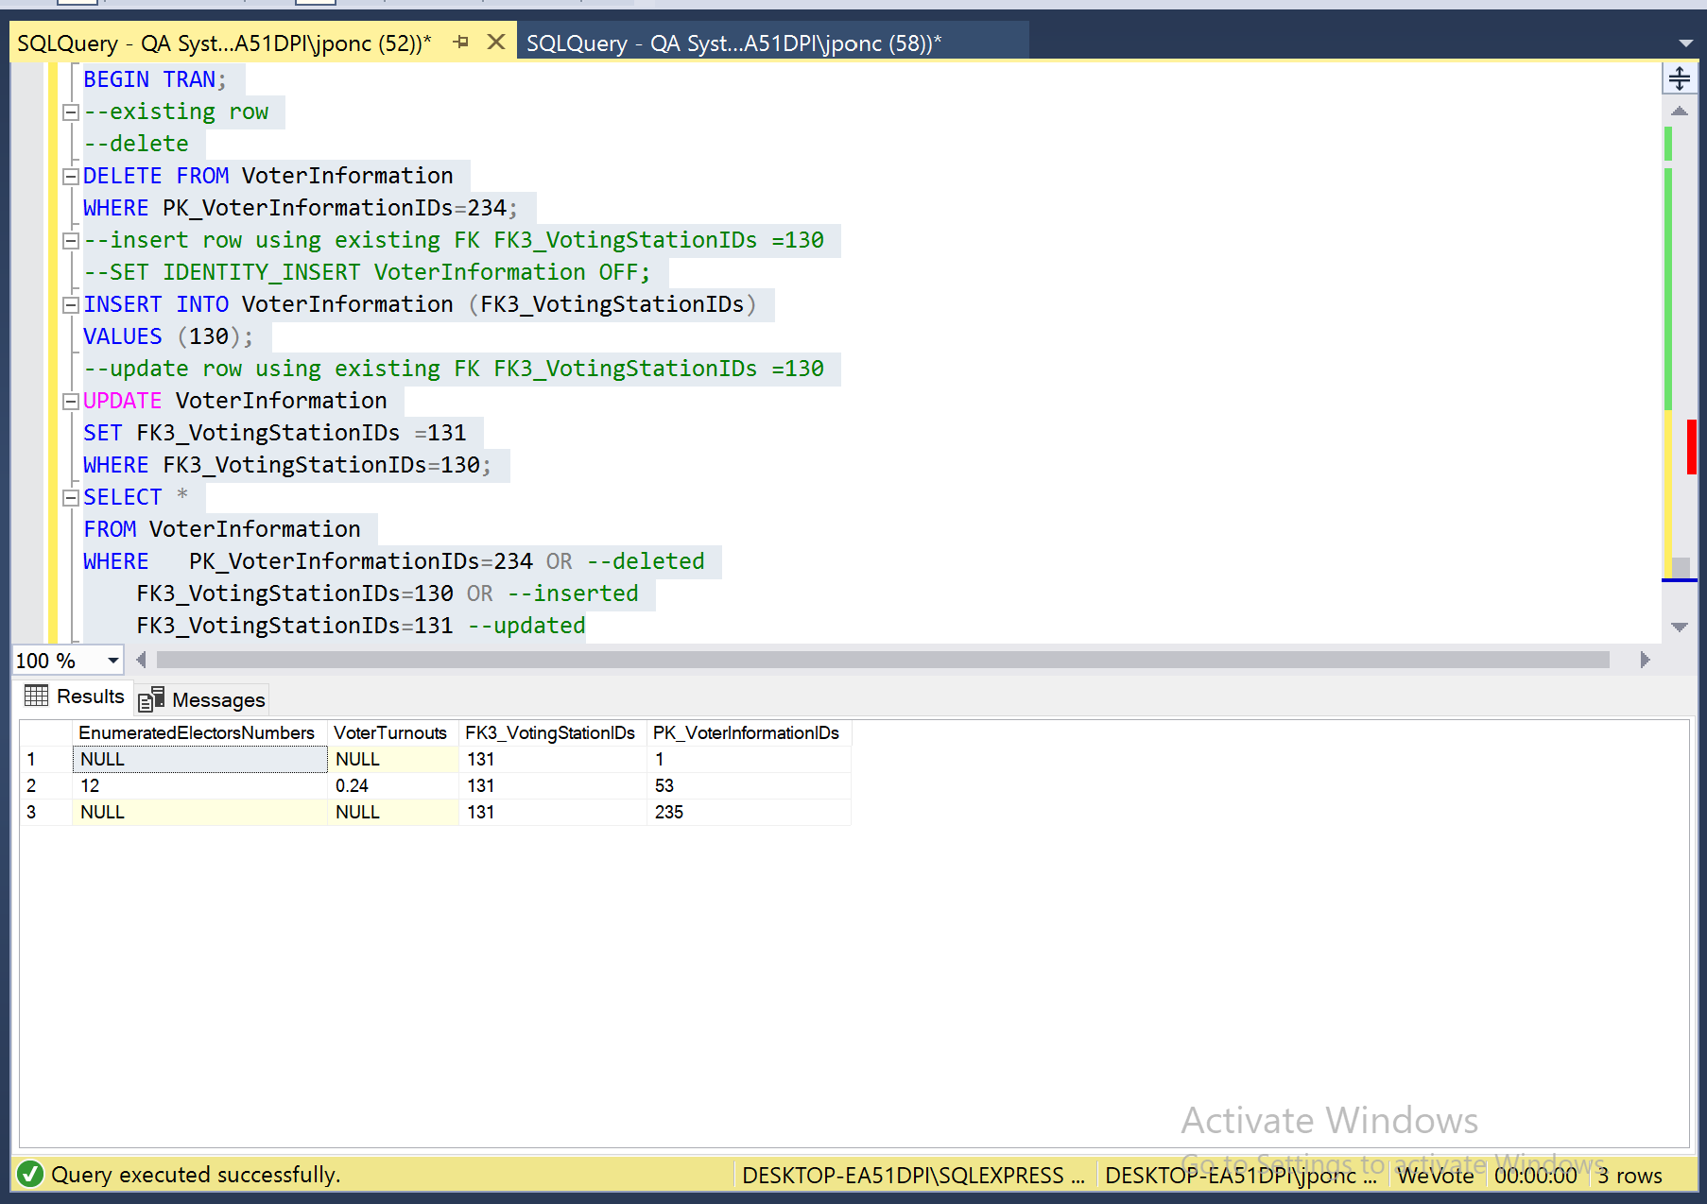

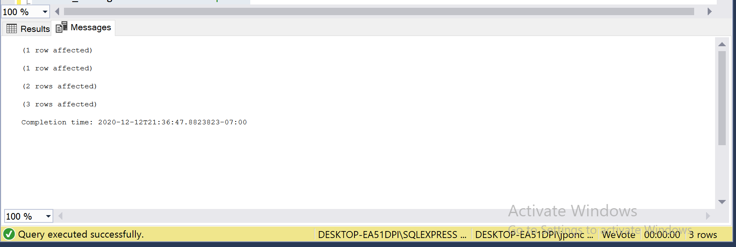

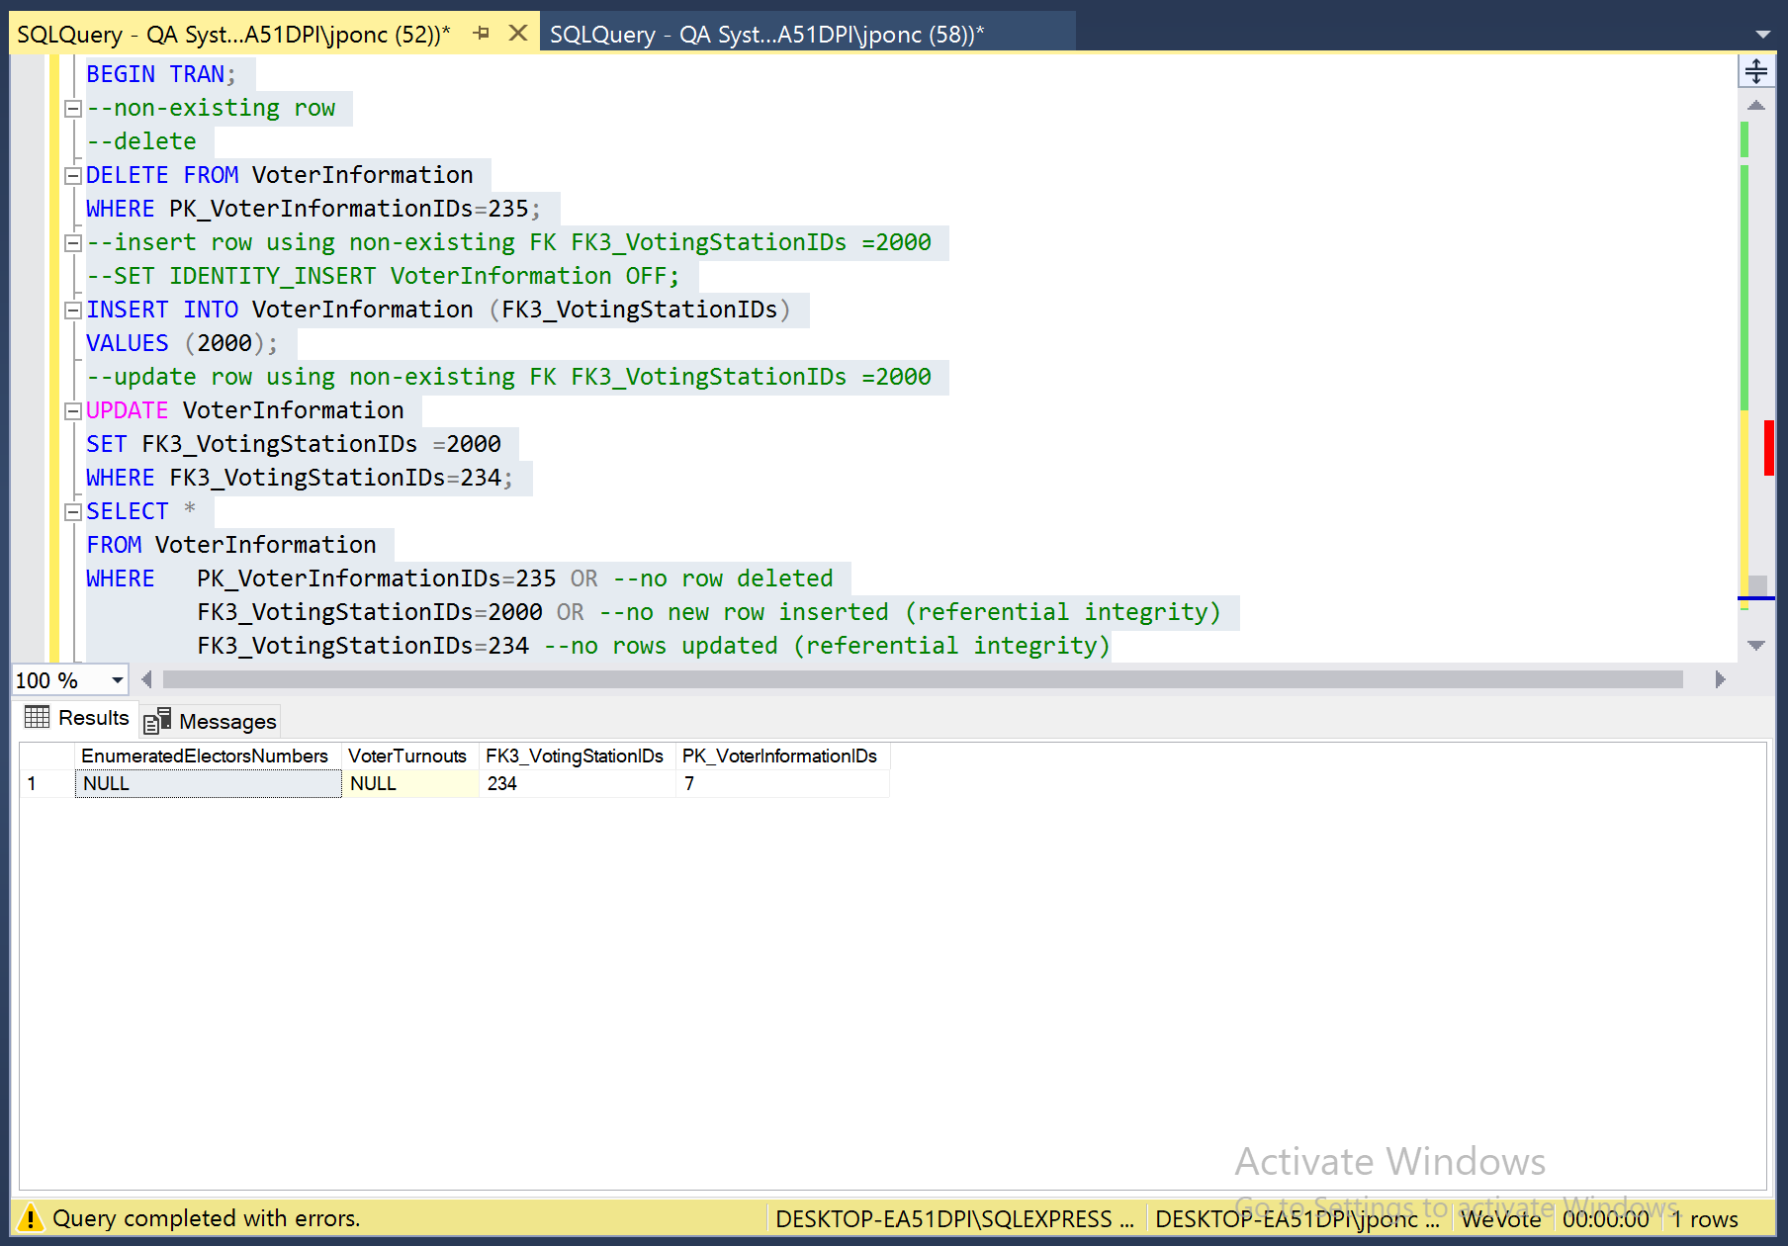

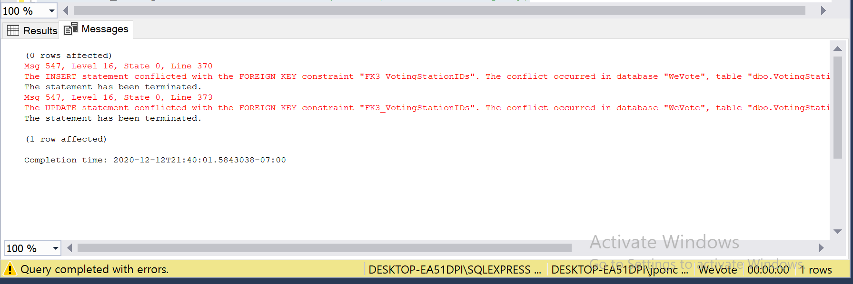

## For table VoterInformation:

The fig below show the column that allow Nulls



Executing

“ Begin Transaction insert into VoterInformation (FK3_VotingStationIDs)

Values('130')”

No error because nulls are allowed in VoterTurnouts

Executing

“ Begin Transaction insert into VoterInformation (VoterTurnouts)

Values('130') ”

Error Cannot insert the value NULL into column 'FK3_VotingStationIDs', table 'WeVote.dbo.VoterInformation'; column does not allow nulls. INSERT fails. Was generated because nulls is not allowed in FK3_VotingStationIDs.

# **VoterInformation** **Table**

Constraint on VoterInformation table

CONSTRAINT [EnumeratedElectorsNumbers] CHECK (([EnumeratedElectorsNumbers]>=(0)))

**Execution**

Begin Transaction

insert into VoterInformation(EnumeratedElectorsNumbers,FK1_VotingStationIDs)

Values('-1','130')

Error The INSERT statement conflicted with the CHECK constraint "EnumeratedElectorsNumbers". The conflict occurred in database "WeVote", table "dbo.VoterInformation", column 'EnumeratedElectorsNumbers'. is generated validating the constraint given

Constraint on VoterInformation table

CONSTRAINT [VoterTurnouts] CHECK (([VoterTurnouts]>=(0)))

**Execution**

Begin Transaction

insert into VoterInformation(VoterTurnouts,FK1_VotingStationIDs)

Values('-1','130')

Error The INSERT statement conflicted with the CHECK constraint "VoterTurnouts". The conflict occurred in database "WeVote", table "dbo.VoterInformation", column 'VoterTurnouts' is generated validating the constraint given